**Name:**

**Section:**

**Date:**

**2510L Final Exam**

1. (a) Identify the mineral and describe what characteristics led you to this decision.

(3 Points)

(b) Identify the mineral and describe what characteristics led you to this decision. (3 Points)

1. (a) Identify the sedimentary rock. What type of sedimentary rock is it (Chemical, Biological, Clastic)? Describe the grain size (**Fine, Medium, Coarse, Crystalline**) and sorting (**Poorly sorted, Well sorted**) if it’s clastic. Describe the mineral composition. (6 Points)

(b) Identify the sedimentary rock. What type of sedimentary rock is it (Chemical, Biological, Clastic)? Describe the grain size (**Fine, Medium, Coarse, Crystalline**) and sorting (**Poorly sorted, Well sorted**) if it’s clastic. Describe the mineral composition. (6 Points)

1. (a) Identify the igneous rock. Describe its texture (**Glassy, Vesicular, Porphyritic, Phaneritic, Aphanitic, Pegmatic**) and mineral composition. (4 Points)

(b) Identify the igneous rock. Describe its texture (**Glassy, Vesicular, Porphyritic, Phaneritic, Aphanitic, Pegmatic**) and mineral composition. (4 Points)

1. (a) Identify the metamorphic rock. Is it **foliated** or **non-foliated**? Describe the grade of metamorphism (**High, Medium, Low, or All**). (4 Points)

(b) Identify the metamorphic rock. Is it **foliated** or **non-foliated**? Describe the grade of metamorphism (**High, Medium, Low, or All**). (4 Points)

1. Contour the map below using a 5’contour interval. (10 Points)

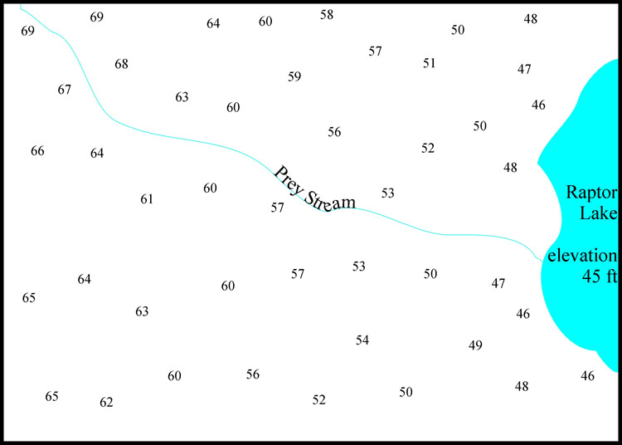

1. How many inches represents a mile if a topographic map has a scale of 1:24,000? (4 Points)
2. Label the zone of aeration, zone of saturation, surface layer, and water table. (7 Points)

D

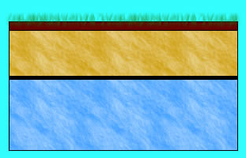

(a) ________________________

(b) ________________________

(c) ________________________

(d) ________________________

C

A

B

1. Match the glacial feature left by glaciation with their respective definition. (6 Points)

**Features: Definitions:**

(1) Horn Bowl – shaped depressions.

(2) Drumlin Sharp, jagged ridges.

(3) Kettle Out-of-place boulders.

(4) Kame Shallow lakes or depressions formed from falling ice chunks.

(5) Cirque Sharp mountain peaks.

(6) Arete Mounds of glacial debris.

(Example) Erratics Streamlined hills (tear drop shaped).

1. Identify the features of the meandering stream in the figure below (1 Point each).

(1)

(2)

(3)

(4)

(5)

(6)

(7)

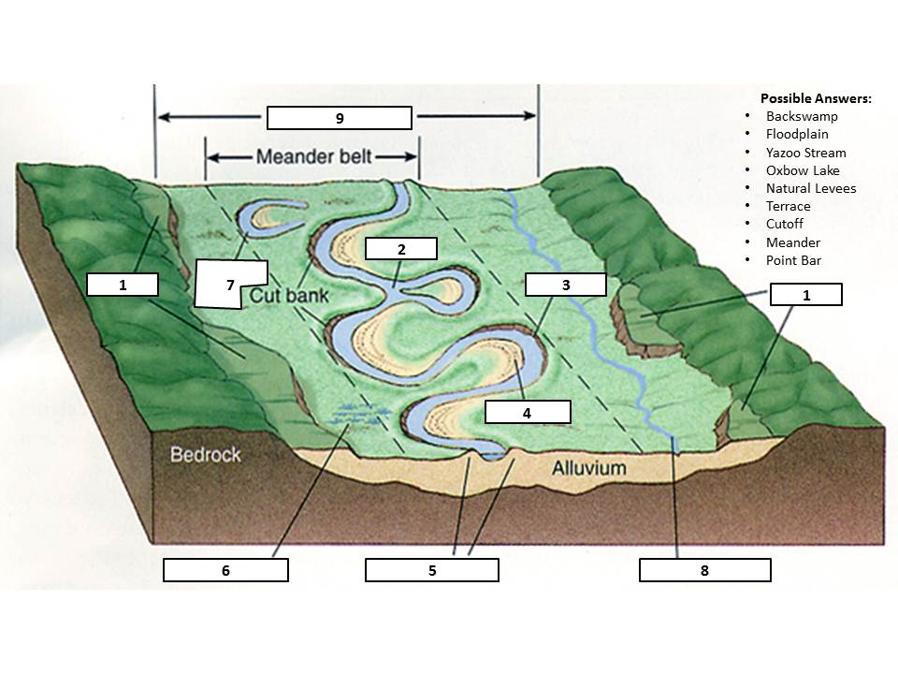(8)

(9)

1. Put the following in order from first to occur to last: surface waves, p-waves, and s-waves. (6 Points) Which one causes the most damage? (2 Points)
2. Draw and label a syncline and anticline. (8 Points)

1. Draw and label a reverse, normal and strike-slip fault. Labels should include fault type, hanging wall, foot wall and displacement arrows. (12 Points)

**BONUS:**

Identify the features shown. (2 Points each)

1. 2.

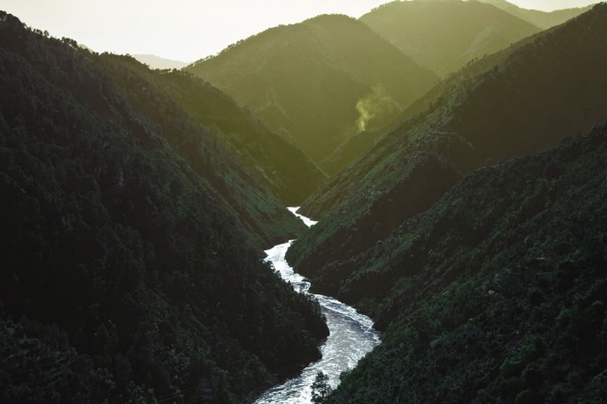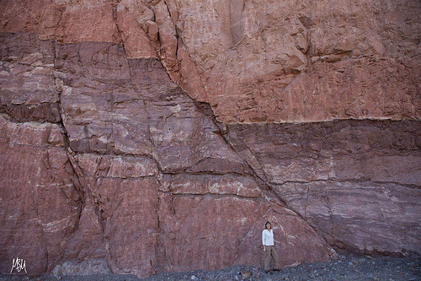

**____________________________________ ___________________________________**

3. 4.

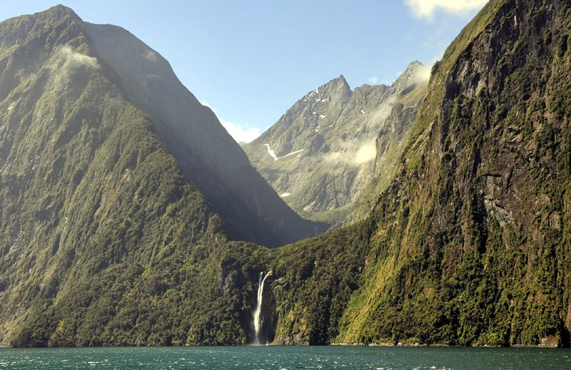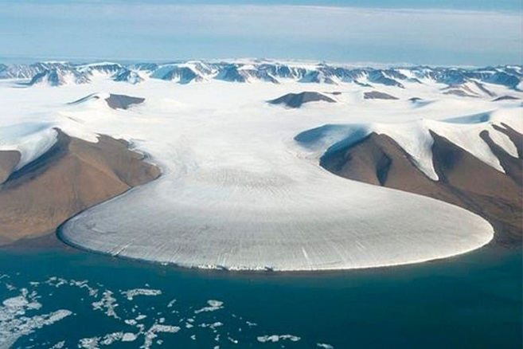

____________________________________ ____________________________________

5.

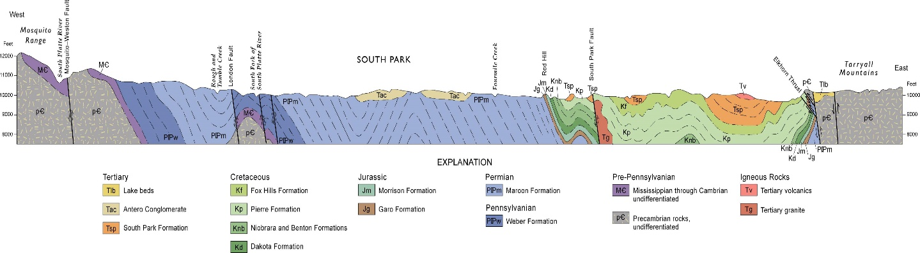

____________________________________ Geologic Map, Cross Section, Topo Map, or DEM?